# **Template – DocuSign Form Sequence with Additional Fields and Routing Order**

The template named “Template – DocuSign Form Sequence with Additional Fields and Routing Order” is applicable to CampusNexus Student.

## Purpose and Outcome

This template provides a form sequence and supporting workflow for a form sequence to be completed and signed by the student and multiple co-signers. This sequence can be used, for example, to collect references required to complete an application form.

The template shows how to:

* Use DocuSign components for additional fields such as SSN, checkboxes, attachments, etc.
* Specify the routing order for multiple DocuSign recipients

The sequence requires the following:

* A complete **Student record** must exist in the CampusNexus Student database.
* The student must have a **Portal login** to log into this authenticated sequence.

Upon completion of the sequence, the workflow creates a PDF of the form sequence and inserts the PDF into the CampusNexus Student Document Center.

## Prerequisites

The template was built with Forms Builder using the applications listed below. The template is forward compatible with later versions of the listed applications.

|  |  |
| --- | --- |
| **Application** | **Minimum Version** |
| Forms Builder Designer and Renderer | 3.6.x |
| Web Client for CampusNexus Student | 20.0 |
| Workflow Composer | 3.0.x |
| Packages installed from Package Manager in Workflow Composer | Activities and Contracts (V1) 20.0.0  Activities and Contracts (V2) 20.0.0  Forms Builder Contracts 3.6.x |
| Workflow Tracking Database | N/A |
| Staff STS 2.0 | 2.1 |

**Prerequisite Settings**

The Multiple Signer feature requires a specific setting in your DocuSign account. To enable the feature, log in to your DocuSign account and navigate to **Account Administration** > **Features**. Select the **DocuSign** Connect check box. This feature must be enabled for the WebHook functionality to work.

Another setting that is available in your CampusNexus Student account is found under **Manage Account** > **Email Notifications**. Here you configure who receives the DocuSign email when the institution is a signer or a sender.

## Step 1: Download and Import the Template

1. Download the template file to your environment (local drive or network location).
2. Log into **Forms Builder Designer**.
3. Click the **Export/Import** tile.
4. Select the **Import** tab.
5. Click **Select exported file** and navigate to the downloaded template file.
6. Click **Import**.

* [Export/Import](https://help.campusmanagement.com/FB/3.x/Content/ExportImport.htm)

The following forms will be imported::

* Welcome
* CMC_Personal_Info_Plus_Additional
* CoSigner_All
* Default-Frame
* DocuSignWait
* Default-Confirmation

## Step 2: In Form Designer…

1. From the **Forms** slide out, select the **CMC_Personal_Info_Plus_Additional** form.
2. Customize the form for your environment. Modify properties on fields/components to make them required, etc., or add/remove fields on form.

This form has multiple **DocuSign** components with *Type* property values other than *Signature* and *Date Signed.* The additional DocuSign components have *Type* values such as *Decline*/Accept *Ssn*, *Checkbox*, *Attachment*, *Company, Date, Number*.

The additional DocuSign components are paired with **HTML** components that describe the expected user input (e.g., <span style="font-size:14px">Co-Signer Decline to Sign Option</span>) and HTML components that provide appropriate spacing in the 2-column layout of the rendered form (HTML-Spacer).

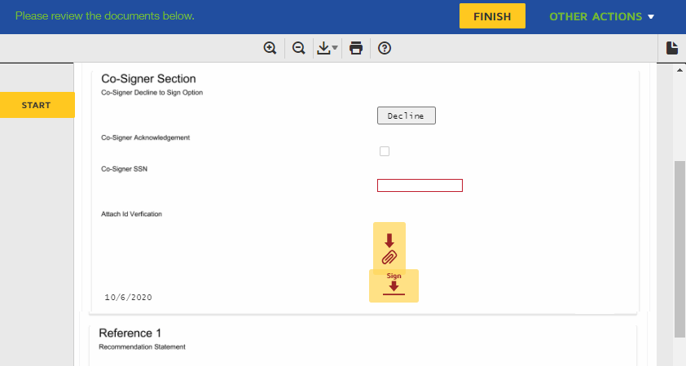

The DocuSign component at the bottom of the form uses the *Type* value *Envelope Id*. This component is required but does not have any user input. The Envelope object is the container for a transaction. The envelope contains the documents for the eSignature transaction and information about the recipients and timestamps that indicate the delivery progress.

Make sure you edit the text in the Labels and other controls as applicable for your institution.

* [Fields](https://help.campusmanagement.com/FB/3.x/Content/Fields.htm) and [Components](https://help.campusmanagement.com/FB/3.x/Content/Components.htm)

1. **Save** the form.
2. Repeat steps 1-3 for the Text Box and HTML components on the **CoSigner_All** form.
3. Adjust the **Welcome** and **Default-Confirmation** forms as appropriate for your institution.

Do not modify the Default-Frame and DocuSignWait forms.

## Step 3: In Sequence Designer…

1. Locate the **CMC_DEMO_Docusign_MultiSign_Template** in the Sequences pane.
2. Click **Save As** to create a copy of the sequence/workflow and customize the copy for your use. This way you can always refer to the original sequence/workflow you downloaded.
3. Optional - Add a custom style (theme) associated with your campus.

* [Themes](https://help.campusmanagement.com/FB/3.x/Content/Themes.htm)

1. Select your saved sequence in the Sequences pane.
2. In the Properties Pane, select **End State Form** “Default-Confirmation”.
3. **Save** the sequence**.**

## Step 4: In Workflow Composer…

1. Open the workflow for your saved sequence.

* [Open the Workflow for a Sequence](https://help.campusmanagement.com/FB/3.x/Content/HostedEnv.htm)

1. Explore the arguments, states, and transitions to get an understanding of the workflow logic.
2. In the “Next” transition after the “CoSigner_All” state, locate the Assign activity for the **DocuSignConfig.EmailSubject** and edit the string value as appropriate for your use case.

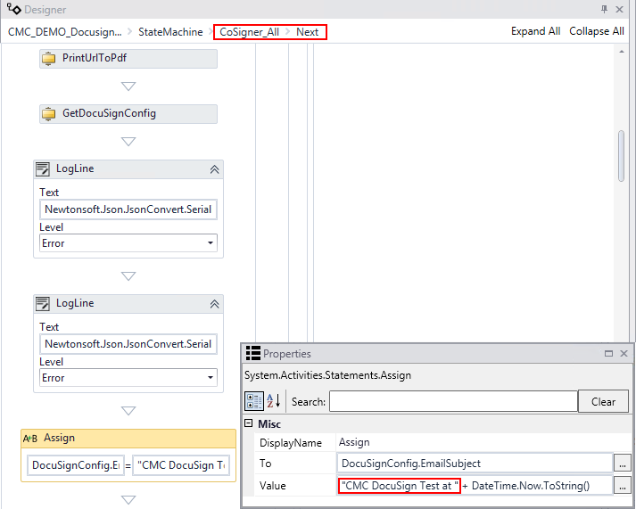

1. Note that the Assign activity for **DocuSignConfig.ReturnUrl** (located below the Assign DocuSignConfig.EmailSubject activity) has a hard-coded Url value based on the form name used in the template. Do not modify this value.

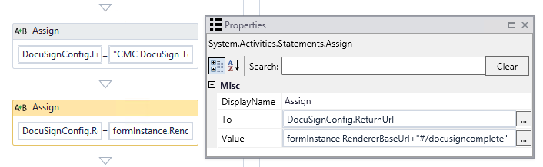

1. The following Assign activity sets the **DocuSignConfig.TestMode** value to True. In a production environment, you will need to set this to **False**.

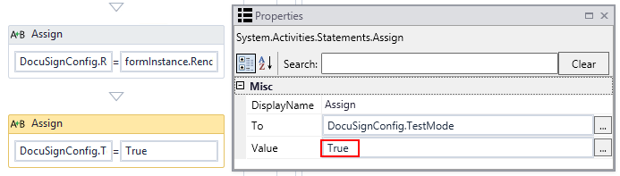

1. Further down in the “Next” transition after the “CoSigner_All” state, note the Assign activities for **DocuSignRecipient2** and **DocuSignRecipient3**. Both recipients are assigned **RoutingOrder “2”**.

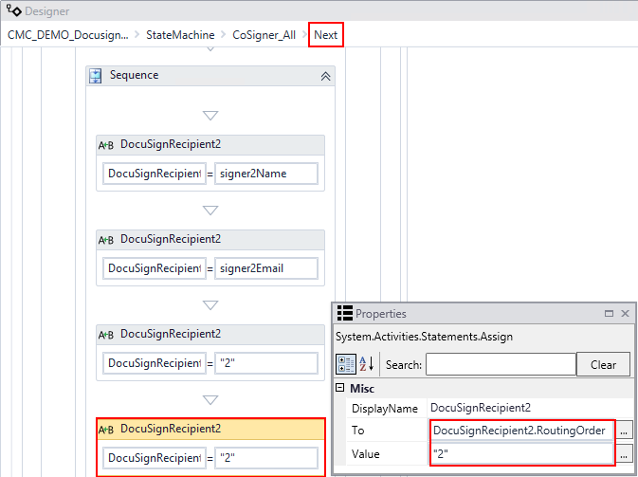

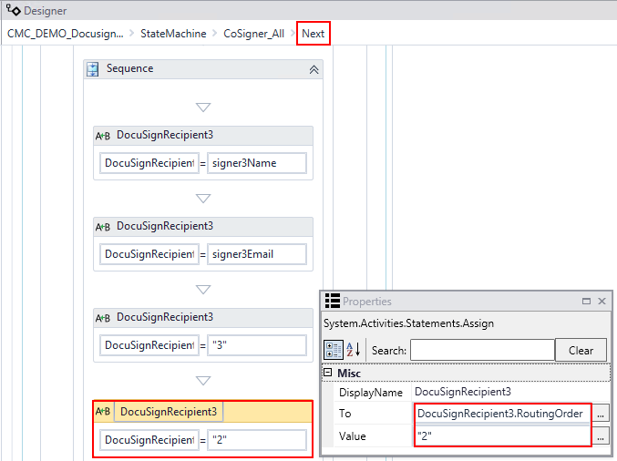

RoutingOrder “2” indicates that DocuSignRecipient2 and DocuSignRecipient3 will simultaneously receive a copy of the completed envelope after DocuSignRecipient1 has completed his/her e-signature actions.

The RoutingOrder property requires your DocuSign account to be configured for sequential signing. For more details, see [Allow Sequential Signing](http://cltcvuehelps/fb/3.x/Content/DocuSignComponent.htm#AllowSequentialSigning) in Forms Builder help.

1. Locate the **CreateDocument** activity in the “Done” transition before the End state form. Select **Document Type** and **Document Status** values appropriate for your environment and use case.

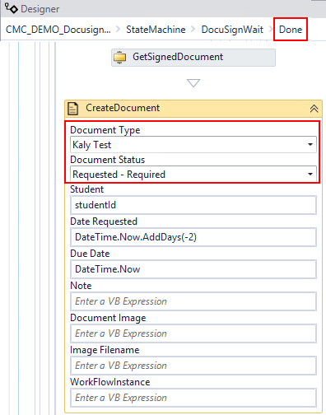

1. Further down in the “Done” transition, update **SendMail** activity for your case.

## Step 5: In Forms Renderer…

Select your sequence and try it out!

* [Sequence List](https://help.campusmanagement.com/FB/3.x/Content/SequenceList.htm)

1. Find your **CMC_DEMO_Docusign_MultiSign_Template** sequenceand copy the **URL** to the clipboard.
2. Paste the URL into a browser and complete the form sequence.
3. In CampusNexus Student, verify that the staff member’s address information is updated as specified in the form sequence.

## Step 6: Lastly…

Once your updated sequence has been tested successfully, it is recommended that you disable the workflow for the original Template version.

1. In Workflow Composer, in the Server section of the ribbon, click **Open**.
2. Find the workflow named **CMC_DEMO_Docusign_MultiSign_Template**.
3. Clear the **Enabled** check box and click **Save**.